MCA-424 Lab Data Structures and Algorithms
-Practical Assignment-
Name :Mahale Rohit Madhavrao
Roll No. : 28 Seat No : 380813
----------------------------------------------------------------------------------------------------------------------------------
- Find the Maximum element in the Array .
#include <iostream>
using namespace std;

void FINDMAX(int DATA[],int N){
int LOC = 0;
int MAXVALUE = DATA[0];

for(int K = 1 ; K < N ; K++){

if(MAXVALUE < DATA[K]){
LOC = K ;
MAXVALUE = DATA[K];
}
}
cout<<"Largest Element : "<<MAXVALUE<<" LOC : "<<LOC<<endl;
}
int main(){
int DATA[] = {70,15,11,12,10,9,14,58,47,51,62,47,26,22,18,17};
int N = sizeof(DATA)/sizeof(DATA[0]);
FINDMAX(DATA,N);
return 0;
}

OUTPUT –
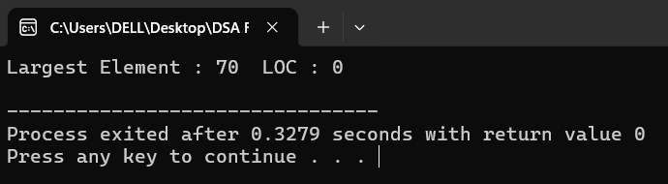

- Traversing in the linear Array.
#include <iostream>
using namespace std;
void PROCESS(int element){
cout<<element<<"\t";
}
void TRAVERSE(int DATA[],int N){
int LB = 0 ;
int UB = N - 1 ;
int K = LB;
while(K<= UB){
PROCESS(DATA[K]);
K = K + 1 ;
}
}
int main(){
int DATA[] = {70,15,11,12,10,9,14,58,47,51,62,47,26,22,18,17};
int N = sizeof(DATA)/sizeof(DATA[0]);
TRAVERSE(DATA,N);
return 0;
}
OUTPUT—
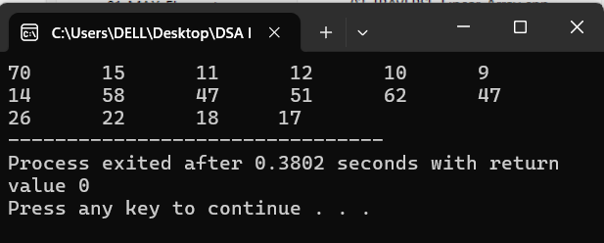

- Insert the element in Linear Array.
#include <iostream>
using namespace std;
void INSERT(int DATA[],int N ,int K, int ITEM){
int J = N - 1 ;
if(DATA[J] != 0){
cout<<"OVERFLOW"<<endl;
return;
}

while (K <= J){
DATA[J + 1] = DATA[J];
J = J - 1;
}
DATA[K] = ITEM;
//N = N + 1 ;
cout<<"After Inserting Element :"<<endl;
for(int i = 0 ; i < N ; i++){
cout<<DATA[i]<<"\t";
}
}
int main(){
int DATA[] = {70,15,11,12,10,9,14,58,47,51,62,47,26,22,18,0};
int N = sizeof(DATA)/sizeof(DATA[0]);
int K = 5 ;
int ITEM = 45;
INSERT(DATA,N,K,ITEM);

return 0;
}

OUTPUT—
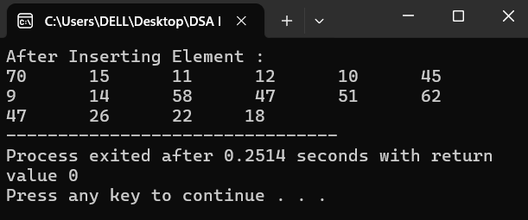

- Deleting the element from Linear Array.
#include <iostream>
using namespace std;
void DELETE(int DATA[],int &N ,int K){
int ITEM = DATA[K];
for(int J = K ; J < N ; J++){
DATA[J] = DATA[J + 1];
}
N = N - 1;
cout<<"After Deleting LOC : "<< K <<endl;
for(int i = 0 ; i < N ; i++){
cout<<DATA[i]<<"\t";
}
}
int main(){
int DATA[] = {70,15,11,12,10,9,14,58,47,51,62,47,26,22,18,73};
int N = sizeof(DATA)/sizeof(DATA[0]);
int K = 6 ;
DELETE(DATA,N,K);

return 0;
}
OUTPUT—
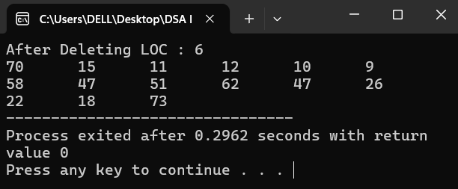

- Searching the element from Linear Array.
#include <iostream>
using namespace std;
void SEARCH(int DATA[] , int N ,int ITEM){
int LOC = -1 ;
for(int i = 0 ; i < N ; i++){
if(DATA[i] == ITEM){
LOC = i ;
}
}
if (LOC != -1) {
cout << ITEM << " found at Location: " << LOC << endl;
} else {
cout << ITEM << " not in Array!!" << endl;
}

}
int main(){
int DATA[] = {70,15,11,12,10,9,14,58,47,51,62,47,26,22,18,73};
int N = sizeof(DATA)/sizeof(DATA[0]);
int ITEM = 12 ;
SEARCH(DATA,N,ITEM);

return 0;
}

OUTPUT—
- Binary Search in Sorted Array.
#include <iostream>
using namespace std;
void BINARY(int DATA[],int N , int LB , int UB ,int ITEM){
int LOC = -1 ;
int BEG = LB ;
int END = UB ;
int MID ;

while(BEG <= END){
MID = (BEG+END)/2 ;
if(DATA[MID] == ITEM){
LOC = MID ;
break ;
}else if(ITEM < DATA[MID]){
END = MID - 1 ;
}else{
BEG = MID + 1 ;
}
}

if (LOC != -1) {
cout << ITEM << " found at Location: " << LOC << endl;
} else {
cout << ITEM << " not in Array!!" << endl;
}
}

int main(){
int DATA[] = {10,12,14,16,18,22,24,36,46,56,57,58,60,65,70,73,79,99};
int N = sizeof(DATA)/sizeof(DATA[0]);
int ITEM = 18 ;
int LB = 0 ;
int UB = N - 1 ;
BINARY(DATA,N,LB,UB,ITEM);

return 0;
}

OUTPUT—
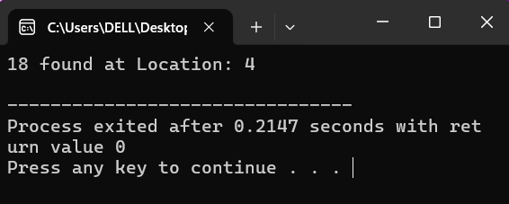

- Matrices Multiplication using Multidimensional Array.
#include <iostream>
using namespace std;
void MATMUL(int A[][3],int B[][2],int M,int N,int P){
int C[M][P];

for(int I = 0 ; I < M ; I++){
for(int J = 0 ; J < P ; J++){
C[I][J] = 0 ;
}
}
for(int I = 0 ; I < M ; I++){
for(int J = 0 ; J < P ; J++){
for(int K = 0 ; K < N ; K++){
C[I][J] = C[I][J] + A[I][K]*B[K][J];
}
}
}
cout<<"MATRICES multiplication :"<<endl;
for(int I = 0 ; I < M ; I++){
for(int J = 0 ; J < P ; J++){
cout<<"C["<<I<<"]["<<J<<"] = "<<C[I][J]<<"\t";
}
cout<<endl;
}
}

int main(){

int A[2][3] = {{20,40,60},{30,50,70}};
int B[3][2] = {{10,30},{20,40},{25,35}} ;
int M = 2 ;
int N = 3 ;
int P = 2 ;
MATMUL(A,B,M,N,P);

return 0;
}
OUTPUT—
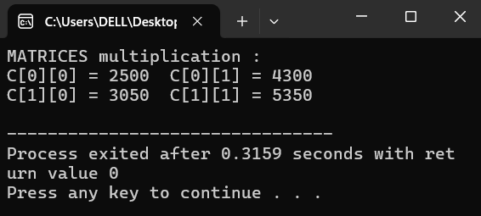

- Inserting the element int the array using Stack.
#include <iostream>
using namespace std;

void PUSH(int STACK[],int MAXSTK,int TOP,int ITEM){
if(TOP == MAXSTK){
cout<<"OVERFLOW !";
return;
}
TOP = TOP + 1 ;
STACK[TOP] = ITEM ;
}
int main(){
int STACK[7] = {10,20,30,40,50};
int MAXSTK = sizeof(STACK)/sizeof(STACK[0]);
int TOP = 4 ;
int ITEM = 55 ;
PUSH(STACK,MAXSTK,TOP,ITEM);
cout<<"After Pushing the element"<<endl;
for(int i = 0 ; i < MAXSTK ; i++){
cout<<STACK[i]<<"\t";
}

return 0;
}
OUTPUT—

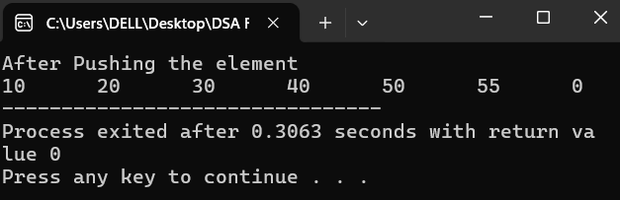

- Deleting the element from the array using Stack.
#include <iostream>
using namespace std;

void POP(int STACK[],int TOP,int ITEM){
if(TOP == 0){
cout<<"UNDERFLOW !";
return;
}
STACK[TOP] = 0;
//TOP = TOP - 1 ;
}
int main(){
int STACK[7] = {10,20,30,40,50};
int MAXSTK = sizeof(STACK)/sizeof(STACK[0]);
int TOP = 4 ;
int ITEM = 0;
POP(STACK,TOP,ITEM);
cout<<"After POP the element"<<endl;
for(int i = 0 ; i < MAXSTK ; i++){
cout<<STACK[i]<<"\t";
}

return 0;
}
OUTPUT—
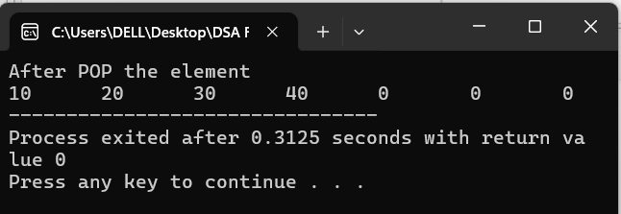

- Converting Infix expression into Postfix expression using Stack .

#include <iostream>
#include <stack>
using namespace std;

int prec(char c) {
if (c == '+' || c == '-') return 1;
if (c == '*' || c == '/') return 2;
if (c == '^') return 3;
return 0;
}

string POLISH(string Q) {
stack<char> S;
S.push('(');
Q += ')';
string P = "";

for (int i = 0; i < Q.length(); i++) {
char c = Q[i];
if (isalnum(c)) {
P += c;
}
else if (c == '(') {
S.push(c);
}
else if (c == ')') {
while (S.top() != '(') {
P += S.top();
S.pop();
}
S.pop();
}
else {
while (!S.empty() && prec(S.top()) >= prec(c)) {
P += S.top();
S.pop();
}
S.push(c);
}
}
return P;
}

int main() {
string Q;
cout << "Enter infix: ";
cin >> Q;
cout << "Postfix: " << POLISH(Q) << endl;
return 0;
}

OUTPUT—
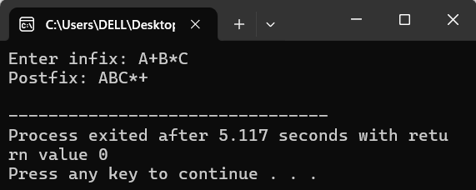

- Calculate the factorial Using recursion.
#include <iostream>
using namespace std;
void FACTORIAL(int &FACT,int N){
if(N == 0){
FACT = 1 ;
return ;
}
int TEMP = FACT;
FACTORIAL( FACT, N - 1 );
FACT = N * FACT ;
}
int main(){

int N = 6 ;
int FACT = 1 ;
FACTORIAL(FACT,N);
cout<<"Factorial of "<<N<<" is = "<<FACT<<endl;
return 0;
}

OUTPUT—
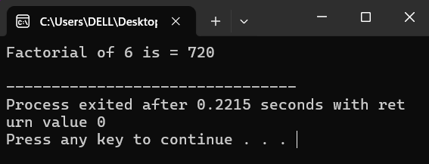

- Find the Nth Fibonacci number using Recursion.
#include <iostream>
using namespace std;
void FIBONACCI(int &FIBO,int N ){
if (N == 0) {
FIBO = 0;
return;
}
if (N == 1) {
FIBO = 1;
return;
}
int FIBA ;
int FIBB ;

FIBONACCI(FIBA,N-1);
FIBONACCI(FIBB,N-2);

FIBO = FIBA + FIBB;
}
int main(){
int N = 10 ;
int FIBO = 0;
FIBONACCI(FIBO,N);
cout<<"FIBO : "<<FIBO<<endl;
return 0;
}
OUTPUT—
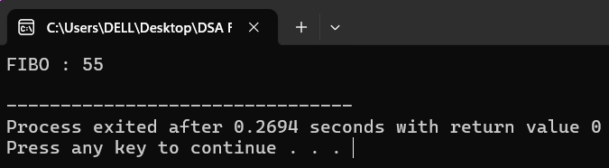

- Inserting the element in the array Using queue.
#include <iostream>
using namespace std;
void INSERT(int QUEUE[],int N ,int FRONT, int REAR,int ITEM){
if(REAR == N - 1 && FRONT == 1 || FRONT = REAR + 1 ){
cout<<"OVERFLOW"<<endl;
return;
}
if(FRONT == -1){
FRONT = 1 ;
REAR = 1 ;
}else if(REAR == N - 1){
REAR = 1 ;
}else{
REAR = REAR + 1 ;
}
QUEUE[REAR] = ITEM ;
}

int main(){

int QUEUE[] = {0,12,15,17,18,19,20,21,0};
int FRONT = 1 ;
int REAR = 7 ;
int N = sizeof(QUEUE)/sizeof(QUEUE[0]);
int ITEM = 25 ;
INSERT(QUEUE,N,FRONT,REAR,ITEM);
for(int i = 0 ; i < N ; i++){
cout<<QUEUE[i]<<"\t";
}

return 0;
}

OUTPUT—
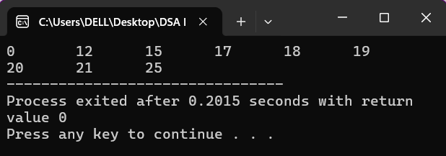

- Deleting the element from the array Using queue.
#include <iostream>
using namespace std;
void DELETE(int QUEUE[],int N ,int &FRONT, int &REAR){
if(FRONT == -1){
cout<<"UNDERFLOW"<<endl;
return;
}
int ITEM = QUEUE[FRONT];
cout << "Deleted Item: " << ITEM << endl;
QUEUE[FRONT] = 0 ;
if(FRONT == REAR){
FRONT = -1 ;
REAR = -1 ;
}else if(FRONT = -1){
FRONT = 0 ;
}else{
FRONT = FRONT + 1 ;
}
while(FRONT != N - 1 ){

QUEUE[FRONT] = QUEUE[FRONT + 1];
FRONT = FRONT + 1 ;
}
}

int main(){

int QUEUE[] = {12,15,17,18,19,20,21,0};
int FRONT = 0;
int REAR = 6 ;
int N = sizeof(QUEUE)/sizeof(QUEUE[0]);
DELETE(QUEUE,N,FRONT,REAR);
for(int i = 0 ; i < N ; i++){
cout<<QUEUE[i]<<"\t";
}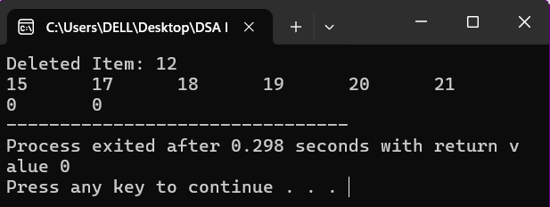

return 0;
}

OUTPUT—

- Traversing in the linked List.
#include <iostream>
using namespace std;
void PROCESS(char element){
cout << element <<" -> ";
}
void TRAVERSE (char INFO[] , int LINK[] , int START){
int PTR = START ;
while(PTR != 0){
PROCESS(INFO[PTR]) ;
PTR = LINK[PTR] ;
}
cout << "NULL" << endl;
}
int main (){
char INFO[] = { ' ', 'B' , 'C' , 'E' , 'A' , 'D'};
int LINK[] = { 0 , 2 , 5 , 0 , 1 , 3 };
int START = 4 ;
TRAVERSE(INFO, LINK , START);

return 0;
}

OUTPUT—
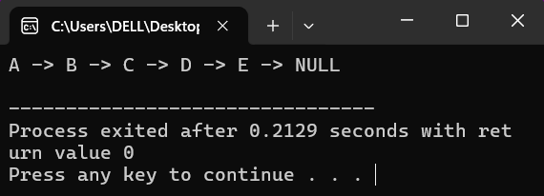

- Searching in the Linked List where List is unsorted.
#include <iostream>
using namespace std;
void SEARCH(int INFO[] , int LINK[] , int START , int ITEM , int &LOC){
int PTR = START ;
while( PTR != 0 ){
if( ITEM == INFO[PTR] ){
LOC = PTR ;
cout<<"Location of ITEM "<<ITEM<<" is : "<<LOC<<endl;
return ;
}
PTR = LINK[PTR] ;
}
cout<<"Search is UNSUCESSFUL !!"<<endl;
}

int main (){
int INFO[] = { 0 , 600 , 300 , 500 , 100 , 400};
int LINK[] = { 0 , 2 , 5 , 0 , 1 , 3 };
int START = 4 ;
int ITEM = 100 ;
int LOC = 0 ;
SEARCH(INFO,LINK,START,ITEM,LOC) ;

return 0;
}

OUTPUT—
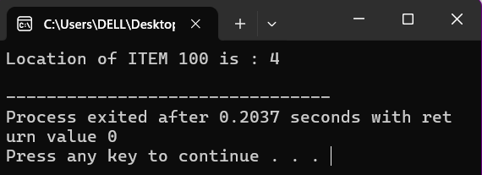

- Searching in the Linked List where List is sorted in ascending order.
//sorted List in ascending order
#include <iostream>
using namespace std;
void SEARCHSL(int INFO[] , int LINK[] , int START , int ITEM , int &LOC){
int PTR = START ;
while( PTR != 0 ){
if( ITEM > INFO[PTR] ){
PTR = LINK[PTR] ;
}else if( ITEM == INFO[PTR] ){
LOC = PTR ;
cout<<"Location of ITEM "<<ITEM<<" is : "<<LOC<<endl;
return ;
}
}
cout<<"Search is UNSUCESSFUL !!"<<endl;
}

int main (){
int INFO[] = { 000 , 200 , 300 , 500 , 100 , 400};
int LINK[] = { 0 , 2 , 5 , 0 , 1 , 3 };
int START = 4 ;
int ITEM = 100 ;
int LOC = 0 ;
SEARCHSL(INFO,LINK,START,ITEM,LOC) ;

return 0;
}
OUTPUT—
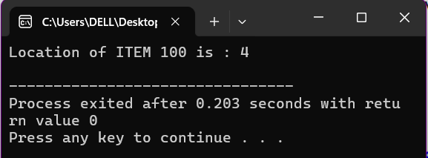

- Searching in the Linked List where List is sorted in descending order.
//sorted List in descending order
#include <iostream>
using namespace std;
void SEARCHSL(int INFO[] , int LINK[] , int START , int ITEM , int &LOC){
int PTR = START ;
while( PTR != 0 ){
if( ITEM < INFO[PTR] ){
PTR = LINK[PTR] ;
}else if( ITEM == INFO[PTR] ){
LOC = PTR ;
cout<<"Location of ITEM "<<ITEM<<" is : "<<LOC<<endl;
return ;
}
}
cout<<"Search is UNSUCESSFUL !!"<<endl;
}

int main (){
int INFO[] = { 0 , 900 , 800 , 600 , 1000 , 700};
int LINK[] = { 0 , 2 , 5 , 0 , 1 , 3 };
int START = 4 ;
int ITEM ;
cout<<"Enter the ITEM for Search : ";
cin>>ITEM;
int LOC = 0 ;
SEARCHSL(INFO,LINK,START,ITEM,LOC) ;

return 0;
}
OUTPUT—
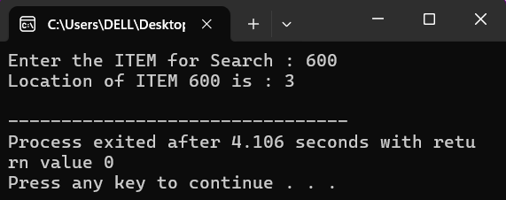

- Inserting the element in the Linked List at the Beginning.
#include <iostream>
using namespace std;

void INSFIRST(int INFO[] , int LINK[] , int &START ,int &AVAIL, int &ITEM){
if(AVAIL == 0 ){
cout<<"OVERFLOW"<<endl;
return;
}
int NEW = AVAIL ;
AVAIL = LINK[AVAIL];

INFO[NEW] = ITEM ;

LINK[NEW] = START ;

START = NEW ;
}
int main (){
int INFO[] = { 0 , 150 , 200 , 0 , 300 , 0 , 0 , 100 , 250 , 0};
int LINK[] = { 0 , 2 , 8 , 9 , 0 , 0 , 5 , 1 , 4 , 6 } ;
int START = 7 ;
int AVAIL = 3 ;
int ITEM = 500 ;

INSFIRST(INFO,LINK,START,AVAIL,ITEM);

cout<<"After Inserting ITEM :: "<<endl;

int N = sizeof(INFO)/sizeof(INFO[0]);

for(int i = 0 ; i < N ; i++ ){
cout<<INFO[i]<<" -> ";
}
cout<<"NULL"<<endl;

cout<<"LINKs"
for(int i = 0 ; i < N ; i++ ){
cout<<LINK[i]<<" -> ";
}
return 0;
}
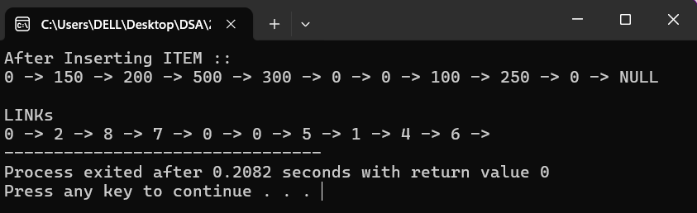
OUTPUT—

- Inserting the element in the Linked List at the Given Location.
//Insertion at given node..
#include <iostream>
using namespace std;
void INSLOC(int INFO[] , int LINK[] , int &START ,int &AVAIL, int &LOC, int &ITEM){
if(AVAIL == 0 ){
cout<<"OVERFLOW"<<endl;
return;
}
int NEW = AVAIL ;
AVAIL = LINK[AVAIL];

INFO[NEW] = ITEM ;

if(LOC == 0 ){
LINK[NEW] = START ;
START = NEW ;
}else{
LINK[NEW] = LINK[LOC];
LINK[LOC] = NEW ;
}
}
int main (){
int INFO[] = { 0 , 150 , 200 , 0 , 300 , 0 , 0 , 100 , 250 , 0};
int LINK[] = { 0 , 2 , 8 , 9 , 0 , 0 , 5 , 1 , 4 , 6 } ;
int START = 7 ;
int AVAIL = 3 ;
int LOC = 8 ;
int ITEM = 500 ;

INSLOC(INFO,LINK,START,AVAIL,LOC,ITEM);

cout<<"After Inserting ITEM :: "<<endl;

int ptr2 = START;
while (ptr2 != 0) {
cout << INFO[ptr2] << " -> ";
ptr2 = LINK[ptr2];
}
cout << "NULL" << endl;

cout << "LINKs" << endl;
ptr2 = START;
while (ptr2 != 0) {
cout << LINK[ptr2] << " -> ";
ptr2 = LINK[ptr2];
}
cout << "NULL" << endl;
return 0;
}
OUTPUT—
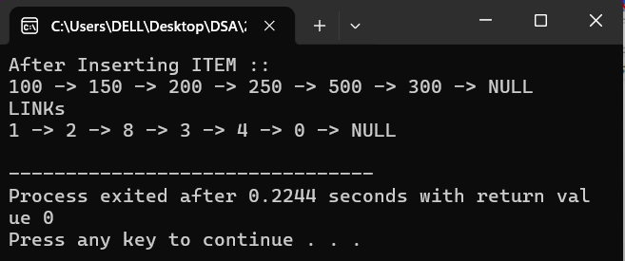

- Inserting the element in the Linked List where list is sorted.
#include <iostream>
using namespace std;
void FINDA(int INFO[],int LINK[],int &START, int &ITEM,int &LOC){
if(START == 0){
cout<<"List is empty !!"<<endl;
return ;
}
if(ITEM < INFO[START]){
LOC = 0 ;
return ;
}
int SAVE = START ;
int PTR = LINK[START] ;

while(PTR != 0){
if (ITEM < INFO[PTR]){
LOC = SAVE ;
return ;
}
SAVE = PTR ;
PTR = LINK[PTR] ;

}
LOC = SAVE ;
}
void INSLOC(int INFO[],int LINK[],int &START , int &AVAIL,int &ITEM,int &LOC){
if(AVAIL == 0){
cout<<"OVERFLOW !!"<<endl;
return ;
}
int NEW = AVAIL ;
AVAIL = LINK[AVAIL] ;

INFO[NEW] = ITEM ;

if(LOC == 0){
LINK[NEW] = START ;
START = NEW ;
}else{
LINK[NEW] = LINK[LOC];
LINK[LOC] = NEW ;
}
}

void INSERT(int INFO[] , int LINK[] , int &START , int &AVAIL, int &ITEM, int &LOC){
FINDA(INFO,LINK,START,ITEM,LOC) ;

INSLOC(INFO, LINK , START, AVAIL, ITEM, LOC);
}

int main (){
int INFO[] = { 0 , 150 , 200 , 0 , 300 , 0 , 0 , 100 , 250 , 0};
int LINK[] = { 0 , 2 , 8 , 9 , 0 , 0 , 5 , 1 , 4 , 6 } ;
int START = 7 ;
int AVAIL = 3 ;
int LOC = 8 ;
int ITEM = 500 ;

INSERT(INFO,LINK,START,AVAIL,ITEM,LOC);

cout<<"After Inserting ITEM :: "<<endl;

int ptr2 = START;
while (ptr2 != 0) {
cout << INFO[ptr2] << " -> ";
ptr2 = LINK[ptr2];
}
cout << "NULL" << endl;

cout << "LINKs" << endl;
ptr2 = START;
while (ptr2 != 0) {
cout << LINK[ptr2] << " -> ";
ptr2 = LINK[ptr2];
}
cout << "NULL" << endl;
return 0;
}
OUTPUT—
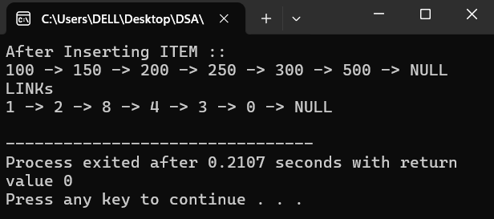

- Delete the Given node from the Linked List.
//Deletion at given node..
#include <iostream>
using namespace std;

DEL(int INFO[],int LINK[],int &START, int &AVAIL, int &LOC , int &LOCP){
if(LOCP == 0 ){
START = LINK[START];
}else{
LINK[LOCP] = LINK[LOC];
}
LINK[LOC] = AVAIL;
AVAIL = LOC ;
}

int main (){
int INFO[] = { 0 , 150 , 200 , 0 , 300 , 0 , 0 , 100 , 250 , 0};
int LINK[] = { 0 , 2 , 8 , 9 , 0 , 0 , 5 , 1 , 4 , 6 } ;
int START = 7 ;
int AVAIL = 3 ;
int LOC = 8 ;
int LOCP = 2 ;

DEL(INFO,LINK,START,AVAIL,LOC,LOCP);

cout<<"After Deleting ITEM :: "<<endl;

int ptr2 = START;
while (ptr2 != 0) {
cout << INFO[ptr2] << " -> ";
ptr2 = LINK[ptr2];
}
cout << "NULL" << endl;

cout << "LINKs" << endl;
ptr2 = START;
while (ptr2 != 0) {
cout << LINK[ptr2] << " -> ";
ptr2 = LINK[ptr2];
}
cout << "NULL" << endl;
return 0;
}

OUTPUT—

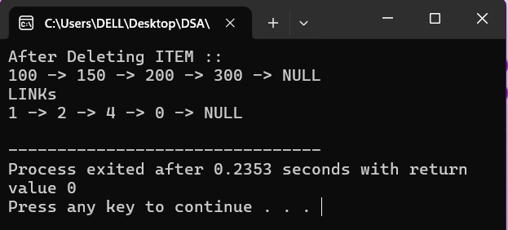

- Traversing into Linked List , List where is Circular Linked List.
#include <iostream>
using namespace std;
void PROCESS(int element){
cout<<element<<"\t";
}
void TRAVERSE(int INFO[],int LINK[],int START){
int PTR = LINK[START];
while(PTR != START){
PROCESS(INFO[PTR]);
PTR = LINK[PTR] ;
}
}
int main(){

int INFO[] = {0 , 12 , 16 , 10 , 15 , 13 , 18 , 14 , 19 , 17 };
int LINK[] = {0 , 5 , 9 , 1 , 2 , 7 , 8 , 4 , 3 , 6 };
int START = 3 ;
TRAVERSE(INFO,LINK,START);
return 0;
}

OUTPUT—
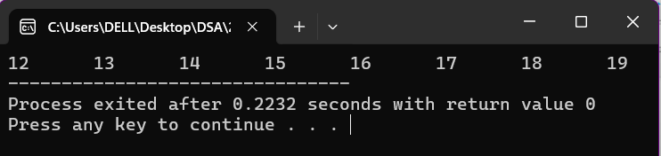

- Deleting the element from Two Way Linked List .
#include <iostream>
using namespace std;
void DELTWL(int INFO[],int FORW[], int BACK[] ,int &FIRST,int &AVAIL,int LOC ){
if (LOC == FIRST) {
FIRST = FORW[LOC];
BACK[FIRST] = 0;
} else {
FORW[BACK[LOC]] = FORW[LOC];
}

if (FORW[LOC] != 0) {
BACK[FORW[LOC]] = BACK[LOC];
}
}
void PROCESS(int element){
cout<<element<<" -> ";
}
void TRAVERSE(int INFO[],int FORW[],int FIRST){
int PTR = FIRST ;
while(PTR != 0){
PROCESS(INFO[PTR]);
PTR = FORW[PTR];
}
}

int main(){
int INFO[] = { 0 , 70 , 20 , 30 , 10 , 90 , 50 , 40 , 80 , 60 };
int FORW[] = { 0 , 8 , 3 , 7 , 2 , 0 , 9 , 6 , 5 , 1 };
int BACK[] = { 0 , 9 , 4 , 2 , 0 , 8 , 7 , 3 , 1 , 6 };
int AVAIL = 0;
int FIRST = 4 ;
int LAST = 5 ;
int LOC = 6 ;
DELTWL(INFO,FORW, BACK,FIRST,AVAIL,LOC );
TRAVERSE(INFO,FORW,FIRST);
cout<<"NULL"<<endl;
return 0;
}
OUTPUT—
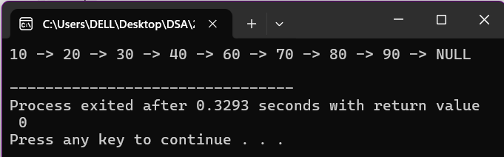

- Inserting the element in Two Way Linked List .
#include <iostream>
using namespace std;

void INSERTTWL(int INFO[], int FORW[], int BACK[], int &FIRST, int &AVAIL, int LOC, int ITEM) {
if (AVAIL == 0) {
cout << "No available space to insert.\n";
return;
}

int NEW = AVAIL;
AVAIL = FORW[AVAIL];

INFO[NEW] = ITEM;

if (LOC == FIRST) {
FORW[NEW] = FIRST;
BACK[FIRST] = NEW;
FIRST = NEW;
BACK[NEW] = 0;
} else {
FORW[NEW] = FORW[LOC];
BACK[NEW] = LOC;
if (FORW[LOC] != 0) {
BACK[FORW[LOC]] = NEW;
}
FORW[LOC] = NEW;
}
}

void PROCESS(int element) {
cout << element << " -> ";
}

void TRAVERSE(int INFO[], int FORW[], int FIRST) {
int PTR = FIRST;
while (PTR != 0) {
PROCESS(INFO[PTR]);
PTR = FORW[PTR];
}
}

int main() {
int INFO[] = { 0 , 70 , 20 , 30 , 10 , 0 , 50 , 40 , 80 , 60 };
int FORW[] = { 0 , 8 , 3 , 7 , 2 , 0 , 9 , 6 , 0 , 1 };
int BACK[] = { 0 , 9 , 4 , 2 , 0 , 0 , 7 , 3 , 1 , 6 };
int AVAIL = 5;
int FIRST = 4;
int LAST = 8;
int LOC = 3;
int VALUE = 100;

INSERTTWL(INFO, FORW, BACK, FIRST, AVAIL, LOC, VALUE);

cout << "Updated Doubly Linked List: ";
TRAVERSE(INFO, FORW, FIRST);
cout << "NULL" << endl;

return 0;
}
OUTPUT—
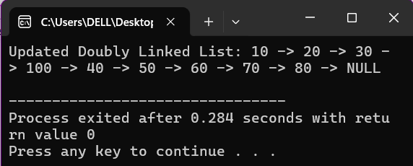

- Sorting the Array Using Bubble Sort .
#include <iostream>
using namespace std;
void BUBBLE(int DATA[],int N){
for(int I = 0 ; I < N ; I++){
int PTR = 0 ;
while(PTR < N){
if(DATA[PTR] > DATA[PTR + 1]){
int TEMP = DATA[PTR];
DATA[PTR] = DATA[PTR + 1];
DATA[PTR + 1] = TEMP;
}
PTR = PTR + 1 ;
}
}
for(int i = 0 ; i < N ; i++){
cout<<DATA[i]<<"\t";
}
}
int main(){
int DATA[] = {44,21,33,14,16,47,95,90,66,84,59};
int N = sizeof(DATA)/sizeof(DATA[0]);
BUBBLE(DATA,N);

return 0;
}
OUTPUT--
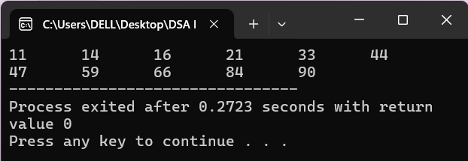

- Sorting the Array Using Insertion Sort .

#include <iostream>
using namespace std;
void INSERTION(int DATA[],int N){
DATA[0] = -1 ;
for(int K = 1 ; K < N ; K++){
int TEMP = DATA[K] ;
int PTR = K - 1 ;
while(TEMP < DATA[PTR]){
DATA[PTR + 1] = DATA[PTR];
PTR = PTR - 1 ;
}
DATA[PTR + 1] = TEMP ;
}
cout<<"Sorted Array :"<<endl;
for(int i = 0 ; i < N ; i++){
cout<<DATA[i]<<"\t";
}
}

int main(){
int DATA[] = {0,44,21,33,14,16,47,95,90,66,84,59};
int N = sizeof(DATA)/sizeof(DATA[0]);
INSERTION(DATA,N);
return 0;
}

OUTPUT—
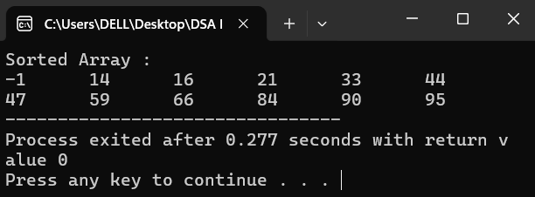

- Sorting the Array Using Selection Sort .
#include <iostream>
using namespace std;
void FINDMIN(int DATA[],int N,int &LOC,int K){
int MIN = DATA[K];
LOC = K ;
for(int J = K + 1 ; J < N ; J++){
if(MIN > DATA[J]){
MIN = DATA[J];
LOC = J ;
}
}
}
void SELECTION(int DATA[],int N){
int LOC;
for(int K = 0 ; K < N ; K++){
FINDMIN(DATA,N,LOC,K);
int TEMP = DATA[K] ;
DATA[K] = DATA[LOC];
DATA[LOC] = TEMP;
}
cout<<"Sorted Array :"<<endl;
for(int i = 0 ; i < N ; i++){
cout<<DATA[i]<<"\t";
}
}
int main(){
int DATA[] = {44,21,33,14,16,47,95,90,66,84,59};
int N = sizeof(DATA)/sizeof(DATA[0]);
SELECTION(DATA,N);
return 0;
}

OUTPUT--
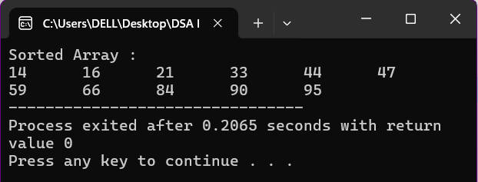

- Sorting the Array Using Merge Sort .
#include <iostream>
using namespace std;

void MERGING(int A[], int R, int B[], int S, int C[],int N) {
int NA = 0;
int NB = 0;
int PTR = 0;

while (NA < R && NB < S) {
if (A[NA] < B[NB]) {
C[PTR] = A[NA];
NA = NA + 1;
} else {
C[PTR] = B[NB];
NB = NB + 1;
}
PTR = PTR + 1 ;
}

while (NA < R) {
C[PTR] = A[NA];
NA = NA + 1 ;
PTR = PTR + 1 ;
}

while (NB < S) {
C[PTR] = B[NB];
NB = NB + 1 ;
PTR = PTR + 1 ;
}
cout<<"After Sorting Array : "<<endl;
for (int i = 0; i < N; i++) {
cout << C[i] << " ";
}
cout << endl;
}

int main() {
int A[] = {10,15,20,25,30,35};
int B[] = {40,45,50,55,60,65,70};
int R = sizeof(A) / sizeof(A[0]);
int S = sizeof(B) / sizeof(B[0]);
int N = R + S;
int C[N];

MERGING(A, R, B, S, C, N);

return 0;
}
OUTPUT--
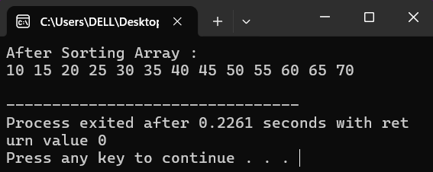

- Sorting the Array Using Quick Sort.
#include <iostream>
using namespace std;

int PARTITION(int DATA[], int START, int END) {
int INDEX = START - 1;
int PIVOT = DATA[END];

for (int i = START; i < END; i++) {
if (DATA[i] <= PIVOT) {
INDEX++;
swap(DATA[i], DATA[INDEX]);
}
}
swap(DATA[INDEX + 1], DATA[END]);
return INDEX + 1;
}

void QUICKSORT(int DATA[], int START, int END) {
if (START < END) {
int PINDX = PARTITION(DATA, START, END);
QUICKSORT(DATA, START, PINDX - 1);
QUICKSORT(DATA, PINDX + 1, END);
}
}

int main() {
int DATA[] = {10, 55, 48, 66, 45, 25, 35, 62, 41, 47, 95, 65, 15, 35, 45, 99, 59, 57};
int N = sizeof(DATA) / sizeof(DATA[0]);
int START = 0 ;
int END = N -1 ;
QUICKSORT(DATA,START,END);

cout << "Sorted array:" << endl;
for (int i = 0; i < N; i++) {
cout << DATA[i] << "\t";
}
cout << endl;

return 0;
}
Output—
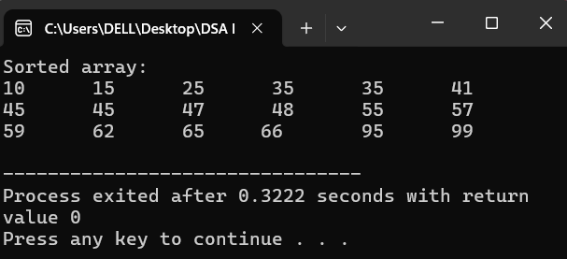

- Traversing on nodes in Pre-order Manner in Binary Tree.
#include <iostream>
using namespace std;

void PreTrav(int TREE[],int INDEX,int SIZE){
if(INDEX >= SIZE || TREE[INDEX] == -1){
return;
}
cout<<TREE[INDEX]<<" - ";
PreTrav(TREE,2 * INDEX,SIZE);
PreTrav(TREE,2 * INDEX + 1 ,SIZE);
}
int main(){
int TREE[] = { 0 , 1 , 2 , 3 , 4 , 5 , 6 , 7 };
int SIZE = sizeof(TREE)/sizeof(TREE[0]);
int INDEX = 1;
PreTrav(TREE,INDEX,SIZE);
return 0;
}
OUTPUT--
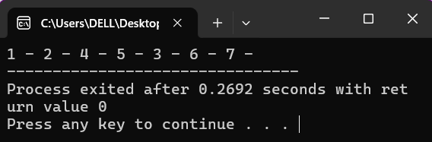

- Traversing on nodes in In-order Manner in Binary Tree.
#include <iostream>
using namespace std;

void InTrav(int TREE[],int INDEX,int SIZE){
if(INDEX >= SIZE || TREE[INDEX] == -1){
return;
}
InTrav(TREE,2 * INDEX,SIZE);
cout<<TREE[INDEX]<<" - ";
InTrav(TREE,2 * INDEX + 1 ,SIZE);
}
int main(){
int TREE[] = { 0 , 1 , 2 , 3 , 4 , 5 , 6 , 7 };
int SIZE = sizeof(TREE)/sizeof(TREE[0]);
int INDEX = 1;
InTrav(TREE,INDEX,SIZE);
return 0;
}
OUTPUT--

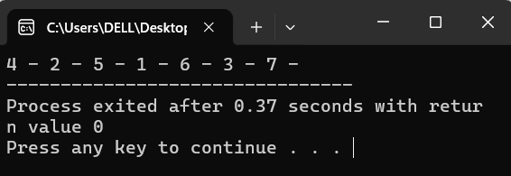

- Traversing on nodes in Post-order Manner in Binary Tree.

#include <iostream>
using namespace std;

void PostTrav(int TREE[],int INDEX,int SIZE){
if(INDEX >= SIZE || TREE[INDEX] == -1){
return;
}
PostTrav(TREE,2 * INDEX,SIZE);
PostTrav(TREE,2 * INDEX + 1 ,SIZE);
cout<<TREE[INDEX]<<" - ";
}
int main(){
int TREE[] = { 0 , 1 , 2 , 3 , 4 , 5 , 6 , 7 };
int SIZE = sizeof(TREE)/sizeof(TREE[0]);
int INDEX = 1;
PostTrav(TREE,INDEX,SIZE);
return 0;
}
OUTPUT--
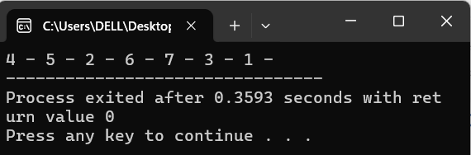

- Searching an element in Binary Tree.
#include <iostream>
using namespace std;

int SEARCH(int TREE[],int INDEX,int SIZE,int ITEM){
int LOC ;
if(INDEX >= SIZE || TREE[INDEX] == -1){
return -1 ;
}
if(TREE[INDEX] == ITEM){
return INDEX ;
}
int LEFT = SEARCH(TREE,2 * INDEX,SIZE,ITEM);
if(LEFT != -1){
return LEFT;
}
int RIGHT = SEARCH(TREE,2 * INDEX + 1 ,SIZE,ITEM);
return RIGHT;

}
int main(){
int TREE[] = { 0 , 1 , 2 , 8 , 4 , 5 , 6 , 7 };
int SIZE = sizeof(TREE)/sizeof(TREE[0]);
int INDEX = 1;
int ITEM;
cout << "Enter the element to search: ";
cin >> ITEM;
int LOC = SEARCH(TREE,INDEX,SIZE,ITEM);
if (LOC != -1) {
cout << "Element " << ITEM << " found at index " << LOC<< "." << endl;
} else {
cout << "Element " << ITEM<< " not found in the tree." << endl;
}
return 0;
}
OUTPUT—
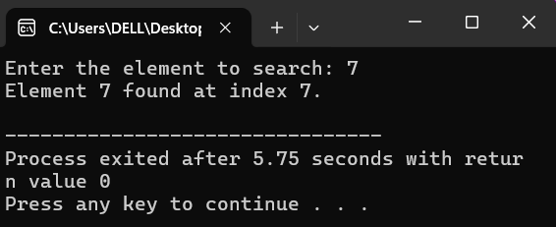

- Inserting an element in Binary Tree.
#include <iostream>
using namespace std;

int INSERT(int TREE[], int INDEX, int SIZE, int ITEM) {
if (INDEX >= SIZE) return -1; // Out of bounds

if (TREE[INDEX] == -1) {
TREE[INDEX] = ITEM;
return INDEX;
}

if (ITEM < TREE[INDEX]) {
return INSERT(TREE, 2 * INDEX, SIZE, ITEM); // Go left
} else if (ITEM > TREE[INDEX]) {
return INSERT(TREE, 2 * INDEX + 1, SIZE, ITEM); // Go right
} else {
return -1; // Duplicate
}
}

int main() {
int TREE[20] = { 0 , 40 , 20 , 70 , 10 , 15 , 50 , 80 , 8 , 12 , -1 , 17 , 45 , 55 , 75 , 85 };
int SIZE = sizeof(TREE) / sizeof(TREE[0]);

// Fill remaining unused indexes with -1
for (int i = 16; i < SIZE; i++) {
TREE[i] = -1;
}

int ITEM;
cout << "Enter the element to insert: ";
cin >> ITEM;

for(int i = 0 ; i < SIZE ;i++){
if(){
TREE[i] = ITEM ;

}
}
int LOC = INSERT(TREE, 1, SIZE, ITEM);
if (LOC != -1) {
cout << "Element " << ITEM << " inserted at index " << LOC << ".\n";
} else {
cout << "Insertion failed: duplicate or tree is full.\n";
}

return 0;
}
OUTPUT--

